TMT/Narasimha Chary/S0491/2025 07-10-2025

To,
Narasimha Chary,
Mobile : 9966131785.

Dear Sir,

SUB :- SUPPLY OF H TYPE HYDRAULIC PRESS
With reference to our discussions regarding your requirement for 50ton H type hydraulic press. We are glad to inform you that, we are in a position to supply you the required equipment. The following are the specifications and our terms and conditions.

S No | Description of the unit | Offer
1. | H type hydraulic press as per photo attached along with 5 hp power pack | Rs 2,80,000/- (Two lakhs Eighty thousand  rupees only)

Terms and conditions:

- Taxes 18% extra.
- Payment 50% order value as advance, balance before delivery.
- Delivery within 20 days from the date of your conformed order along with advance.
- Guarantee: one year against any manufacturing defects.

We are sure you will find our offer in line with your requirements. Should you require any clarification please call us to mobile number 98492 07176. Mail id: md@technomachinetools.in

Thanking you and assuring you of our best services
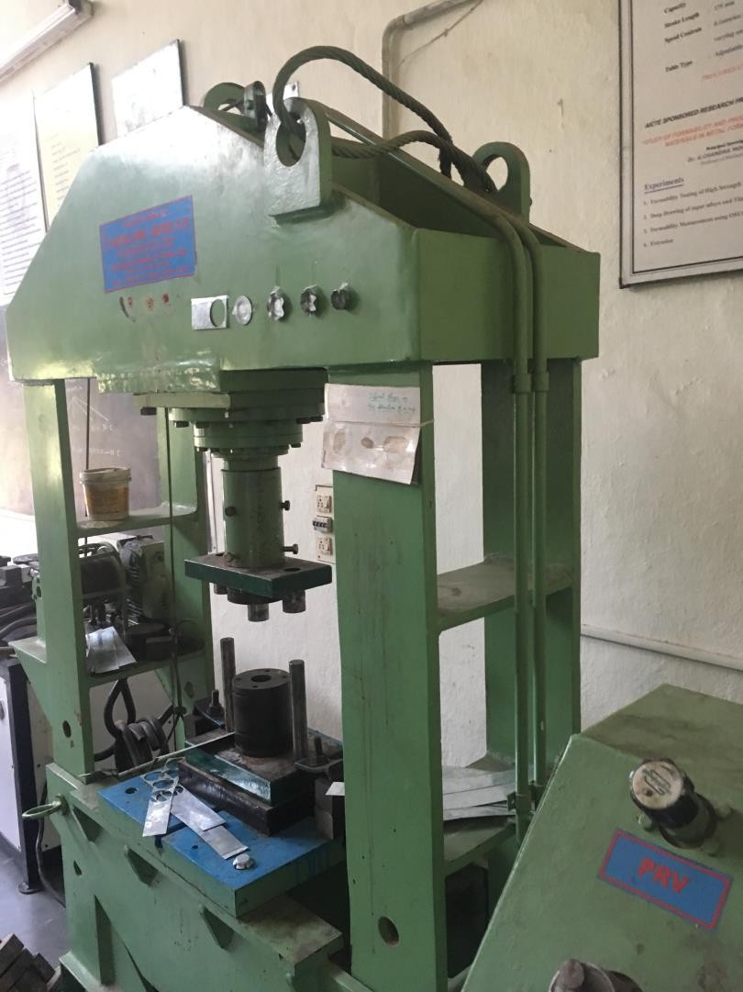

For TECHNO MACHINE TOOLS

( T. SIVARAMAKRISHNA)

